1.GIT-HOL
Step 1: Setup your machine with Git Configuration

1. To check if Git client is installed properly
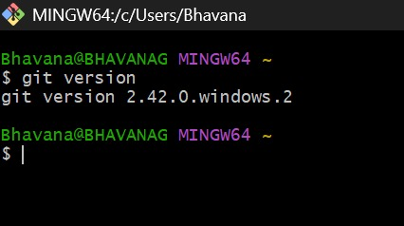

2. To configure user level configuration of user ID and email ID execute

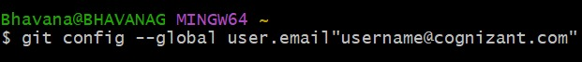

3. To check if the configuration is properly set
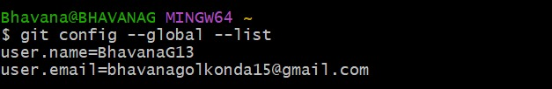

Step 2: Integrate notepad.exe to Git and make it a default editor
1. To check, if notepad.exe execute from git bash

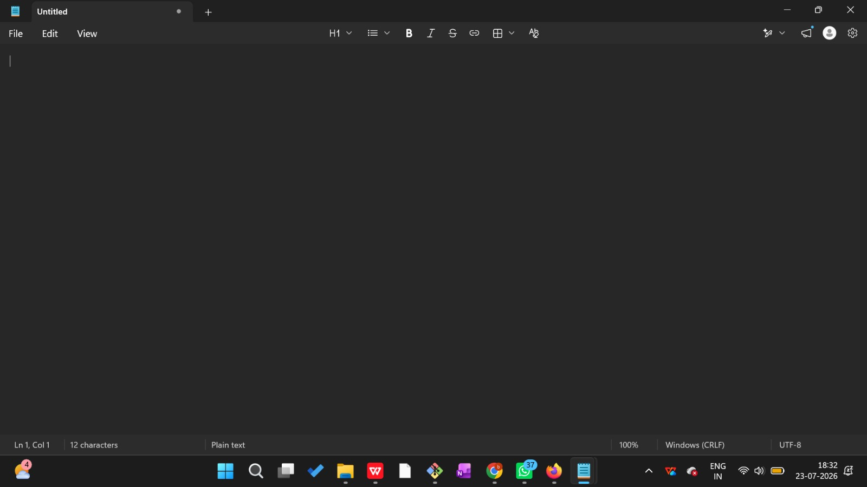

Step 3: Add a file to source code repository
1.Open Git bash shell and create a new project “GitDemo” by executing the command
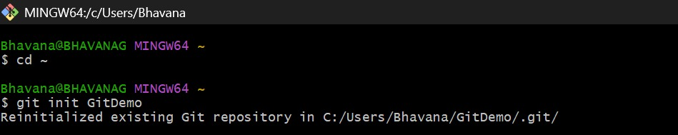

2.To initialize git repository named “GitDemo”
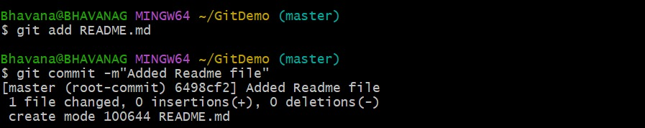
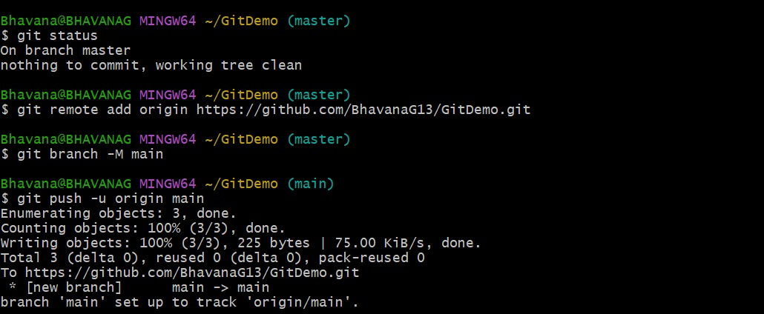
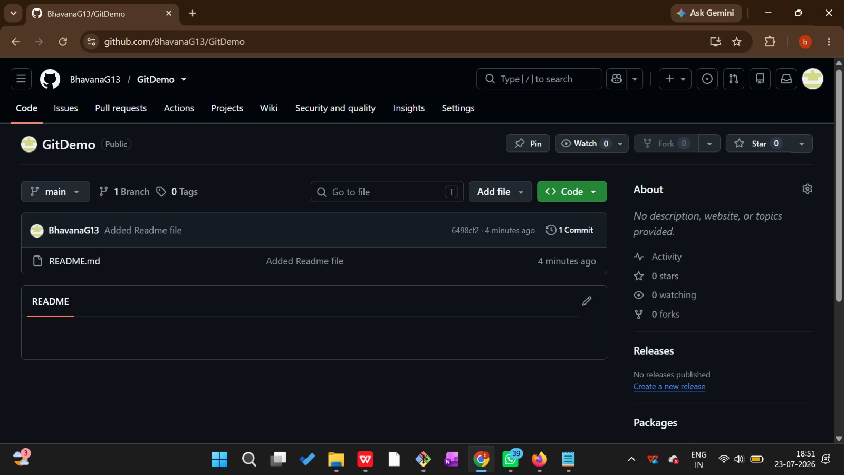

3. To create a file “welcome.txt” and add content to the file
welcome to the version control
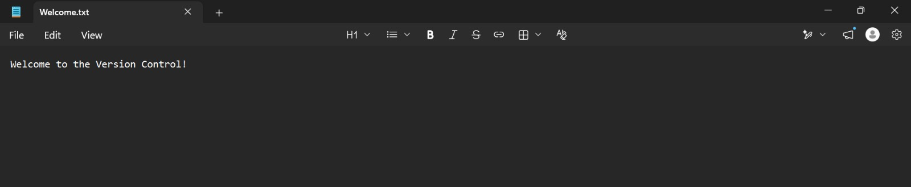

4. To verify if the file “welcome.txt” is created
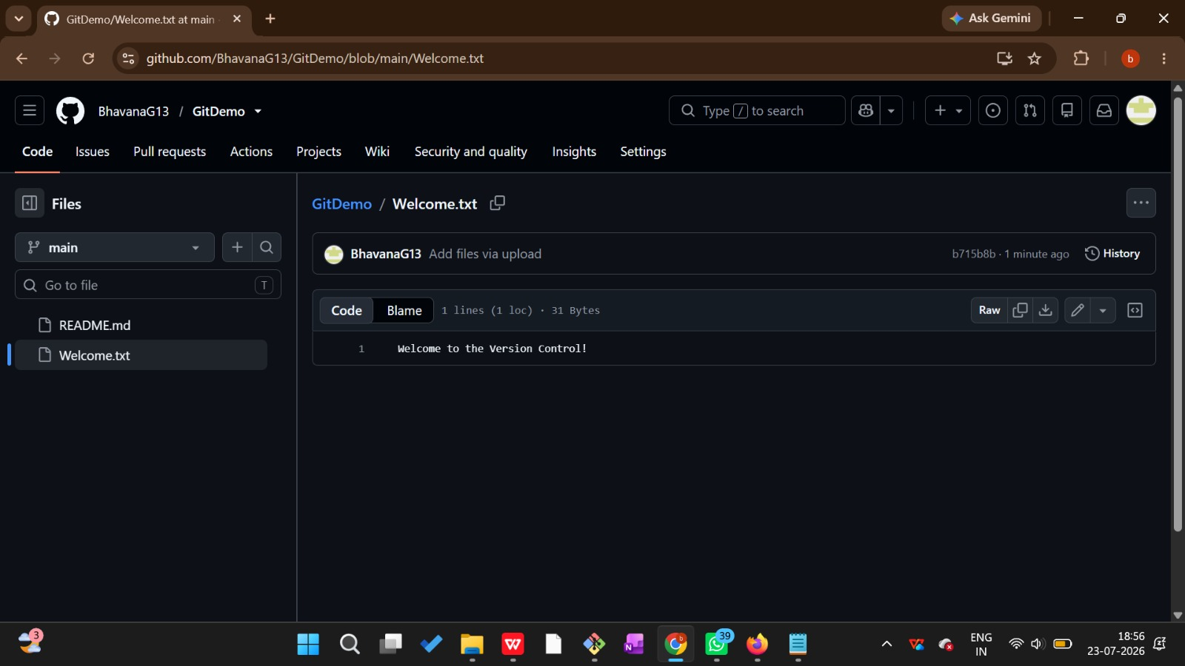

5. To verify the content
git status:
